Digital Communication Systems

**Laboratory Report**

Fall 2021

|  |  |
| --- | --- |
| Laboratory Number: | **07** |
| Laboratory Title: | **Phase Shift Keying pt. 2** |
| Full Name: | **Robert Louis Bara** |
| TUID: | **915614617** |

**Description:**

This week’s lab continues the discussion of Phase Shift Keying by designing a 16PSK to be compared to last week’s 4PSK. By implementing a 16PSK, more symbols will be generated resulting in larger messages to be sent. PSK modulation uses a synchronous detection due to the large carrier frequency. By using a carrier frequency for transmission, the power spectral density of the carrier frequency yields an impulse which results in an impulse shape when examining the power spectral density of the PSK waveform. This lab will compare the signal to noise ratio and mean absolute error between a 4PSK and 16PSK, while also examining the power spectral density plots of baseband signal, carrier signal, modulated signal, and noisy modulated signal.

**Images:**

Figure 1. Symbol's indices and phases for transmitting TU ID

Figure 2. PSK of Transmitted TU ID

Figure . Power Spectrum of Baseband Signal

Figure . Power Spectrum of Carrier Signal

Figure . Power Spectrum of Modulated Signal

Figure . Power Spectrum of Noisy Modulated Signal

**Numerical Tables:**

Observing the 4-ASK table from last week’s lab.

Table 1. 4-PSK SNR vs Mean Absolute Error

|  |  |
| --- | --- |
| 4-PSK | |
| SNR | Mean Absolute Error |
| 20 | 0 |
| 8 | 0 |
| 0 | 0 |
| -8 | 0 |
| -16 | 0 |
| -20 | 0 |
| -24 | 0.0250 |

Generating 1000 samples and observing the SNR in a 16PSK transmission.

Table . 16-PSK SNR vs Mean Absolute Error

|  |  |
| --- | --- |
| 16-ASK | |
| SNR | Mean Absolute Error |
| 20 | 0 |
| 8 | 0 |
| 0 | 0 |
| -8 | 0 |
| -16 | 0.099 |
| -20 | 0.32 |
| -24 | 0.617 |

Comparing the 4PSK table versus the 16PSK table, there is more error as the signal to noise ratio is decreased and there are more symbols.

Figure 7. 4PSK vs 16PSK

**Code:**

### Section 01

The initial parameters are usually defined at the beginning of the program.

%TUID 915614617

clc; clear;

A = 1; % Signal amplitude

rb = 2000; % Fundamental frequency of signal

Tb = 1 / rb; % Period of signal

fc = (6+20) * rb;

Tc = 1 / fc;

fs = 100 * fc; % Sampling frequency

Ts = 1 / fs; % Sampling period

### Section 03

#### Phase Shift Keying (ASK)

Suppose there are 4 symbols in the symbol set. Therefore, at least 4 bits are needed to encode the symbols in binary format.

M = 16; % Number of symbols

Nb = ceil(log2(M)); % Number of bits per symbol

In PSK encoding, the phase will carry the information. So, the phase of the sinosoid will be changed by the symbols.

For example:

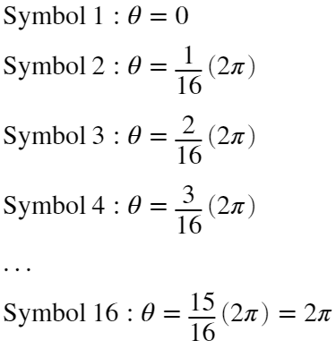

This symbol sets can be shown in the original indices and the PSK encoded format:

symbol_set = 1:M; % symbols' indices

TUID6=4;

%symbol_phase=[pi+5*TUID6,((pi/2)+5*TUID6),(pi+5*TUID6),(3*pi+5*TUID6)] %symbol phases using my TUID

%symbol_phase = [pi/4, 3*pi/4, 5*pi/4, 7*pi/4]; % symbols' phase

symbol_phase = (symbol_set-1)./M * 2 * pi; % symbols' phase